
CMR INSTITUTE OF TECHNOLOGY
ACADEMIC YEAR 2024-2025(EVEN SEM)
Video Session REPORT
DEPARTMENT OF ISE
Subject code | BCS401 | Course Name | Analysis and Design of Algorithms
Semester / Section | IV-C | Prepared By | Ms. Kavitha P
Curriculum Gap Identified: | Subject is at the basic level and much of the application is not covered

Summary of Video Classes Conducted:
Sl No. | Topic | Date | Duration | Total number of students
1 | Decrease and conquer & Insertion Sort | 27/03/2026 | 40 min | 40
2 | P and NP Problem
3 | Decision Tree

Detailed Report
1 | Topic : Decrease and conquer & Insertion Sort | Date: 27/03/2026 | Total Duration: 40 min | Total number of students: 40
Materials Shared Before class

Analysis and design of algorithms material was shared with students through study material website. The proof link of study Materials is shared in advance and the link is given below.

https://www.vtustudymaterials.online/ise/sem4
Link to the Videos:-
Decrease and Conquer- https://www.youtube.com/watch?v=nKzEJWbkPbQ
Insertion sort- https://vlab.andcollege.du.ac.in/csSc/insertion_sort/simulation/index.html

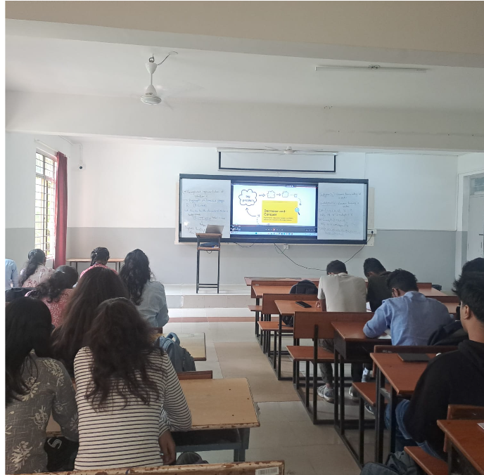

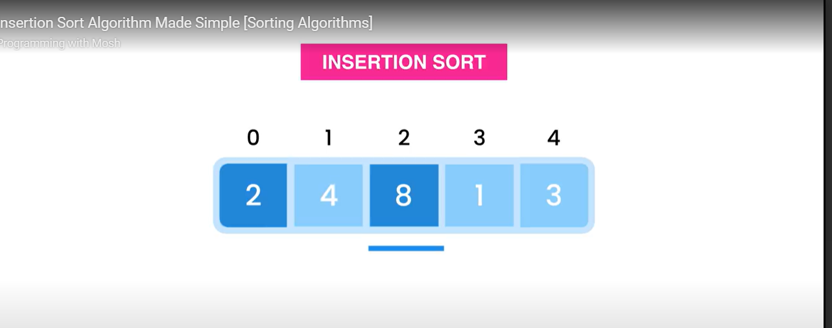

Outcome
The video session is used to address the curriculum gaps if any, by introducing students to get the idea of Heap and heap sort
PO 1,2,3,4.5,9 and PSO 1 and 3 were addressed during this video session

